Chapter 13
Investor Behavior and Capital Market Efficiency
13-1. Assume that all investors have the same information and care only about expected return and volatility. If new information arrives about one stock, can this information affect the price and return of other stocks? If so, explain why.
Yes. When the new information arrives, it will change the attractiveness of this stock. If other stock prices do not change, then investors would want to increase their weight in this stock, implying they would not be holding the market portfolio.
13-2. Assume that the CAPM is a good description of stock price returns. The market expected return is 7% with 10% volatility and the risk-free rate is 3%. New news arrives that does not change any of these numbers but it does change the expected return of the following stocks:
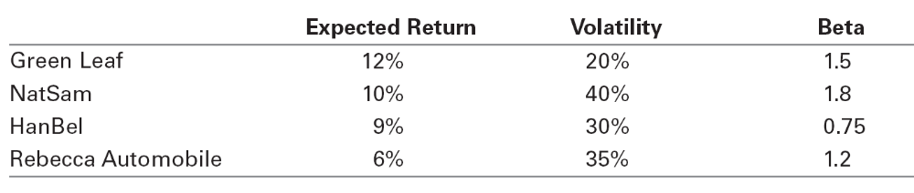
a. At current market prices, which stocks represent buying opportunities?
b. On which stocks should you put a sell order in?

According to the CAPM, we should hold the market portfolio. But once new news arrives and we update our expectations, we may find profitable trading opportunities if we can trade before prices fully adjust to the news. Assuming we initially hold the market portfolio, we can improve gain by investing more in stocks with positive alphas and less in stocks with negative alphas.
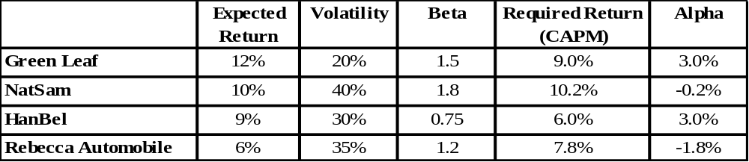
a. Green Leaf, HanBel
b. Rebecca Automobile and possibly NatSam (although its alpha is close enough to zero that we might regard it as insignificant).
13-3. Suppose the CAPM equilibrium holds perfectly. Then the risk-free interest rate increases, and nothing else changes.
a. Is the market portfolio still efficient?
b. If your answer to part (a) is yes, explain why. If not, describe which stocks would be buying opportunities and which stocks would be selling opportunities.
a. No
b. Stocks with betas (calculated using the market portfolio prior to the interest rate change) greater than one will have positive alphas and so would be buying opportunities. Similarly stocks with betas less than one will be selling opportunities.
13-4. You know that there are informed traders in the stock market, but you are uninformed. Describe an investment strategy that guarantees that you will not lose money to the informed traders and explain why it works.
Invest in the market portfolio. Because the average investor must hold the market, by investing in the market you guarantee the average investor return. If the informed traders make higher returns than the average investor, somebody must make lower returns, so by holding the market you can guarantee that it is not you.
13-5. What are the only conditions under which the market portfolio might not be an efficient portfolio?
The market portfolio can be inefficient (so it is possible to beat the market) only if a significant number of investors either:
1. Do not have rational expectations, so that they misinterpret information and believe they are earning a positive alpha when they are actually earning a negative alpha, or
2. Care about aspects of their portfolios other than expected return and volatility, and so are willing to hold inefficient portfolios of securities.
13-6. Explain what the following sentence means: The market portfolio is a fence that protects the sheep from the wolves, but nothing can protect the sheep from themselves.
By investing in the market portfolio, investors can protect themselves from being exploited by investors with better information than they have themselves. By choosing not to invest in the market portfolio, investors expose themselves to being exploited. If they do this because of overconfidence, they will lose money.
13-7. You are trading in a market in which you know there are a few highly skilled traders who are better informed than you are. There are no transaction costs. Each day you randomly choose five stocks to buy and five stocks to sell (by, perhaps, throwing darts at a dartboard).
a. Over the long run will your strategy outperform, underperform, or have the same return as a buy and hold strategy of investing in the market portfolio?
b. Would your answer to part (a) change if all traders in the market were equally well informed and were equally skilled?
a. You will underperform for two reasons: (1) transaction costs and (2) you will lose every time you trade with an informed investor. Of course in this problem only (2) will cause underperformance.
b. This time the only source of losses are transaction costs. In this case, your trades should break even so you should earn the same return.
13-8. Why does the CAPM imply that investors should trade very rarely?
Because they should hold the market portfolio which is a value-weighted portfolio and thus requires no retrading when prices change to maintain the value weights.
13-9. Your brother Joe is a surgeon who suffers badly from the overconfidence bias. He loves to trade stocks and believes his predictions with 100% confidence. In fact, he is uninformed like most investors. Rumors are that Vital Signs (a startup that makes warning labels in the medical industry) will receive a takeover offer at $20 per share. Absent the takeover offer, the stock will trade at $15 per share. The uncertainty will be resolved in the next few hours. Your brother believes that the takeover will occur with certainty and has instructed his broker to buy the stock at any price less than $20. In fact, the true probability of a takeover is 50%, but a few people are informed and know whether the takeover will actually occur. They also have submitted orders. Nobody else is trading in the stock.
a. Describe what will happen to the market price once these orders are submitted if in fact the takeover will occur in a few hours. What will your brother’s profits be: positive, negative or zero?
b. What range of possible prices could result once these orders are submitted if the takeover does not occur? What will your brother’s profits be: positive, negative or zero?
c. What are your brother’s expected profits?
a. In this case the informed traders and your brother will both submit buy orders for any price less than 20, so the only market clearing price is $20, and nobody trades. Zero profits.
b. In this case the informed traders will submit sell orders for any price above $15 and your brother will submit his buy order for any price below $20. Trade will occur at some price in between and your brother will make negative profits.
c. Negative
13-10. To put the turnover of Figure 13.3 into perspective, let’s do a back of the envelope calculation of what an investor’s average turnover per stock would be were he to follow a policy of investing in the S&P 500 portfolio. Because the portfolio is value weighted, the trading would be required when Standard and Poor’s changes the constituent stocks. (Let’s ignore additional, but less important reasons like new share issuances and repurchases.) Assuming they change 23 stocks a year (the historical average since 1962) what would you estimate the investor’s per stock share turnover to be? Assume that the average total number of shares outstanding for the stocks that are added or deleted from the index is the same as the average number of shares outstanding for S&P 500 stocks.
46/523 = 8.8%.
13-11. How does the disposition effect impact investors’ tax obligations?
The disposition effect causes investors to sell stocks that have appreciated and hold onto stocks that have depreciated. Thus investors are paying capital gains taxes that they could defer and deferring tax deductions they could take immediately. Because of the time value of money, these investors are therefore increasing their required tax obligations.
13-12. Consider the price paths of the following two stocks over six time periods:
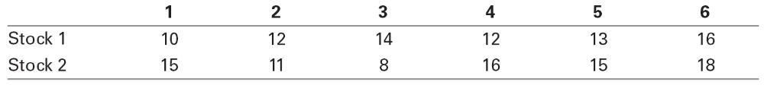
Neither stock pays dividends. Assume you are an investor with the disposition effect and you bought at time 1 and right now it is time 3. Assume throughout this question that you do no trading (other than what is specified) in these stocks.
a. Which stock(s) would you be inclined to sell? Which would you be inclined to hold onto?
b. How would your answer change if right now is time 6?
c. What if you bought at time 3 instead of 1 and today is time 6?
d. What if you bought at time 3 instead of 1 and today is time 5?
a. sell 1, hold 2
b. sell both
c. sell both
d. sell 2, hold 1
13-13. Suppose that all investors have the disposition effect. A new stock has just been issued at a price of $50, so all investors in this stock purchased the stock today. A year from now the stock will be taken over, for a price of $60 or $40 depending on the news that comes out over the year. The stock will pay no dividends. Investors will sell the stock whenever the price goes up by more than 10%.
a. Suppose good news comes out in 6 months (implying the takeover offer will be $60). What equilibrium price will the stock trade for after the news comes out, that is, the price that equates supply and demand?
b. Assume that you are the only investor who does not suffer from the disposition effect and your trades are small enough to not affect prices. Without knowing what will actually transpire, what trading strategy would you instruct your broker to follow?
a. $55.
b. Buy if the price goes up by 10% or more.
13-14. Davita Spencer is a manager at Half Dome Asset Management. She can generate an alpha of 2% a year up to $100 million. After that her skills are spread too thin, so she cannot add value, and her alpha is zero. Half Dome charges a fee of 1% per year on the total amount of money under management (at the beginning of each year). Assume that there are always investors looking for positive alpha and no investor would invest in a fund with a negative alpha. In equilibrium, that is, when no investor either takes out money or wishes to invest new money,
a. What alpha do investors in Davita’s fund expect to receive?
b. How much money will Davita have under management?
c. How much money will Half Dome generate in fee income?
a. Zero
b. $200 million
c. $2 million
13-15. Assume the economy consisted of three types of people. 50% are fad followers, 45% are passive investors (they have read this book and so hold the market portfolio), and 5% are informed traders. The portfolio consisting of all the informed traders has a beta of 1.5 and an expected return of 15%. The market expected return is 11%. The risk-free rate is 5%.
a. What alpha do the informed traders make?
b. What is the alpha of the passive investors?
c. What is the expected return of the fad followers?
d. What alpha do the fad followers make?
a. 1%
b. 0
c. 10.6%
d. –0.1%
13-16. Explain what the size effect is.
The size effect is the empirical observation that firms with lower market capitalizations on average have higher average returns.
13-17. Assume all firms have the same expected dividends. If they have different expected returns, how will their market values and expected returns be related? What about the relation between their dividend yields and expected returns?
Firms with higher expected returns will have lower market values, and firms with high dividend yields will have high expected returns.
13-18. Each of the six firms in the table below is expected to pay the listed dividend payment every year in perpetuity.
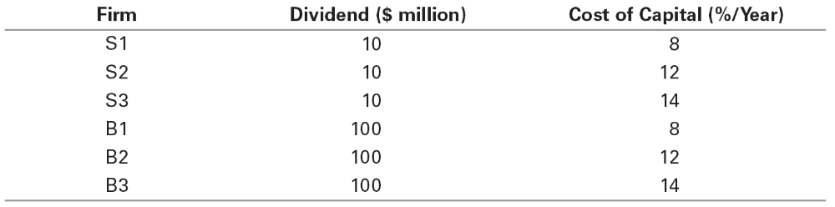
a. Using the cost of capital in the table, calculate the market value of each firm.
b. Rank the three S firms by their market values and look at how their cost of capital is ordered. What would be the expected return for a self-financing portfolio that went long on the firm with the largest market value and shorted the firm with the lowest market value? (The expected return of a self-financing portfolio is the weighted average return of the constituent securities.) Repeat using the B firms.
c. Rank all six firms by their market values. How does this ranking order the cost of capital? What would be the expected return for a self-financing portfolio that went long on the firm with the largest market value and shorted the firm with the lowest market value?
d. Repeat part (c) but rank the firms by the dividend yield instead of the market value. What can you conclude about the dividend yield ranking compared to the market value ranking?
a.
Firm | Dividend | Cost of Capital | Market value
S1 | 10 | 8% | $125.00
S2 | 10 | 12% | $83.33
S3 | 10 | 14% | $71.43
B1 | 100 | 8% | $1,250.00
B2 | 100 | 12% | $833.33
B3 | 100 | 14% | $714.29
b.
Firm | Market Value | Cost of Capital | Self financing weights
S1 | $125.00 | 8% | 1
S2 | $83.33 | 12%
S3 | $71.43 | 14% | (1.00)
B1 | $1,250.00 | 8% | 1
B2 | $833.33 | 12%
B3 | $714.29 | 14% | (1.00)
 | E[R] (S firms) | –6.00%
 | E[R] (B firms) | –6.00%
c.
Firm | Market Value | Cost of Capital | Self financing weights
B1 | $1,250.00 | 8% | 1
B2 | $833.33 | 12%
B3 | $714.29 | 14%
S1 | $125.00 | 8%
S2 | $83.33 | 12%
S3 | $71.43 | 14% | (1.00)
 | E[R] (All firms) | –6.00%
Firms will lower costs of capital tend to be higher in this sort, but the ranking is not perfect.
d.
Firm | Market Value | Dividend yield/Cost of Capital | Self financing weights
S1 | $125.00 | 8% | (1.00)
B1 | $1,250.00 | 8%
S2 | $83.33 | 12%
B2 | $833.33 | 12%
S3 | $71.43 | 14%
B3 | $714.29 | 14% | 1.00
 | E[R] (All firms) | 6.00%
Because the dividend yield equals the cost of capital, the sort ranks firms perfectly (in contrast to parts (b) and (c))—firms with higher dividend yields have higher costs of capital.
13-19. Consider the following stocks, all of which will pay a liquidating dividend in a year and nothing in the interim:
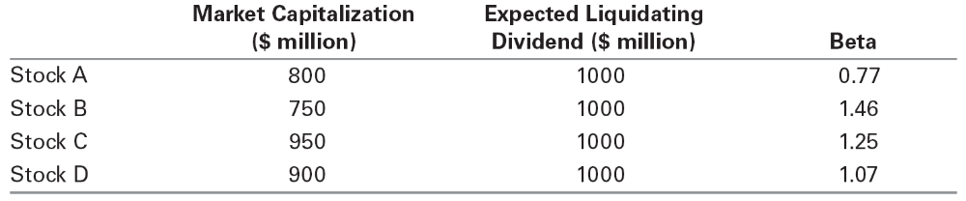
a. Calculate the expected return of each stock.
b. What is the sign of correlation between the expected return and market capitalization of the stocks?

 | Market Capitalization ($ million) | Total Liquidating Dividend ($ million) | Beta | Expected Return
Stock A | 800 | 1,000 | 0.77 | 0.25
Stock B | 750 | 1,000 | 1.46 | 0.33333333
Stock C | 950 | 1,000 | 1.25 | 0.05263158
Stock D | 900 | 1,000 | 1.07 | 0.11111111
 |  |  |  | Correlation
 |  |  |  | –0.9984206

13-20. In Problem 19, assume the risk-free rate is 3% and the market risk premium is 7%.
a. What does the CAPM predict the expected return for each stock should be?
b. Clearly, the CAPM predictions are not equal to the actual expected returns so the CAPM does not hold. You decide to investigate this further. To see what kind of mistakes the CAPM is making, you decide to regress the actual expected return onto the expected return predicted by the CAPM. What is the intercept and slope coefficient of this regression?
c. What are the residuals of the regression in (d)? That is, for each stock, compute the difference between the actual expected return and the best fitting line given by the intercept and slope coefficient in (b).
d. What is the sign of the correlation between the residuals you calculated in (e) and market capitalization?
e. What can you conclude from your answers to part (b) of the previous problem and part (d) of this problem about the relation between firm size (market capitalization) and returns? (The results do not depend on the particular numbers in this problem. You are welcome to verify this for yourself by redoing the problems with another value for the market risk premium, and by picking the stock betas and market capitalizations randomly.)

 | Market Capitalization ($ million) | Total Liquidating Dividend ($ million) | Beta | Expected Return | CAPM | Error | Residual + Intercept | Just Residual
Stock A | 800 | 1000 | 0.77 | 0.25 | 0.0839 | 0.1661 | 0.18430808 | 0.08337312
Stock B | 750 | 1000 | 1.46 | 0.33333333 | 0.1322 | 0.20113333 | 0.22982353 | 0.12888858
Stock C | 950 | 1000 | 1.25 | 0.05263158 | 0.1175 | –0.0648684 | –0.0393684 | –0.1403034
Stock D | 900 | 1000 | 1.07 | 0.11111111 | 0.1049 | 0.00621111 | 0.02897663 | –0.0719583

Risk Free rate | Market Risk Premium |  | Correlation | Slope | Intercept | Intercept | Correlation
3% | 7.00% |  | –0.9984206 | 0.78297881 | 0.10093495 | 0.10093495 | –0.9968741
13-21. Explain how to construct a positive-alpha trading strategy if stocks that have had relatively high returns in the past tend to have positive alphas, and stocks that have had relatively low returns in the past tend to have negative alphas.
You buy stocks that have done well in the past and sell stocks that have done poorly.
13-22. If you can use past returns to construct a trading strategy that makes money (has a positive alpha), it is evidence that market portfolio is not efficient. Explain why.
If the market portfolio is efficient, then all stocks have zero alphas, and you could not construct any strategy that has a positive alpha.
13-23. Explain why you might expect stocks to have nonzero alphas if the market proxy portfolio is not highly correlated with the true market portfolio, even if the true market portfolio is efficient.
Because the proxy portfolio is not highly correlated with the market portfolio, it will not capture some components of systematic risk. The alphas reflect the risk components that the proxy portfolio is not capturing.
13-24. Explain why, if some investors are subject to systematic behavioral biases while others pick efficient portfolios, the market portfolio will not be efficient.
The market portfolio consists of the combination of all investors’ portfolios. Because some investors hold inefficient portfolios that depart from being efficient in systematic ways, the sum of all these investors’ portfolios is not efficient. Since the rest of investors hold efficient portfolios, the sum of all investors’ portfolios will not be efficient.
13-25. Explain why an employee who cares only about expected return and volatility will likely underweight the amount of money he invests in his own company’s stock relative to an investor who does not work for his company.
Employees are already partially invested in their company due to their human capital. Their optimal diversification strategy should take this into account, and thus should underweight their own company’s stock.
For Problems 26–28, refer to the following table of estimated factor betas based on data from 2003-2011.
Factor | MSFT | XOM | GE
MKT | 0.965 | 0.808 | 1.183
SMB | –0.295 | –0.812 | –0.475
HML | –0.099 | 0.196 | 0.965
PR1YR | 0.089 | 0.376 | –0.200

13-26. Using the factor beta estimates in the table shown here and the expected return estimates in Table 13.1, calculate the risk premium of General Electric stock (ticker: GE) using the FFC factor specification. (Annualize your result by multiplying by 12.) GE’s CAPM beta over the same time period was 1.33. How does the risk premium you would estimate from the CAPM compare?
Factor GE
MKT 0.61 1.183
SMB 0.25 –0.475
HML 0.38 0.965
PR1YR 0.70 –0.200

Risk Premium (monthly) 0.83%
RP annual 9.95%
The Annual RP produced by the CAPM beta = 1.33 × 0.61% × 12 = 9.74%
13-27. You are currently considering an investment in a project in the energy sector. The investment has the same riskiness as Exxon Mobil stock (ticker: XOM). Using the data in Table 13.1 and the table above, calculate the cost of capital using the FFC factor specification if the current risk-free rate is 3% per year.
 | Factor | XOM
MKT | 0.61 | 0.808
SMB | 0.25 | -0.812
HML | 0.38 | 0.196
PR1YR | 0.70 | 0.376

Risk Premium (monthly) | 0.63%
RP annual | 7.53%
R_{f} | 3.00%
Cost of capital | 10.53%
13-28. You work for Microsoft Corporation (ticker: MSFT), and you are considering whether to develop a new software product. The risk of the investment is the same as the risk of the company.
- Using the data in Table 13.1 and in the table above, calculate the cost of capital using the FFC factor specification if the current risk-free rate is 3% per year.
- Microsoft’s CAPM beta over the same period was 0.84. What cost of capital would you estimate using CAPM?
 | Factor | MSFT
MKT | 0.61 | 0.965
SMB | 0.25 | -0.295
HML | 0.38 | -0.099
PR1YR | 0.70 | 0.089

Risk Premium (monthly) | 0.54%
RP annual | 6.47%
R_{f} | 3.00%
Cost of capital | 9.47%
CAPM cost of capital | 6.15%

